Challenge - 06 - Ansible
Create ci pipeline that will deploy and configure these VMs using terraform and ansible
according following requirements
1. Deploy 2 virtual machines using terraform.
first vm on Amazon linux, hostname: c8.local
second vm on ubuntu 21.04, hostname: u21.local
2. As a result of terraform execution, dynamically create inventory for ansible
c8.local should be in the frontend group
u21.local should be in the backend group
3. Create ansible playbook for c8.local and u21.local
for linux OS playbook should apply the following changes
selinux: disable
firewalld: disable
for frontend playbook group should install and configure nginx
nginx configuration should do proxying from port 80 on port 19999 to the
backend group
for the backend group, the playbook must install the Netdata application from the
official repositories and run it on port 19999.

To create and execute this pipeline first we need to create one git repository.

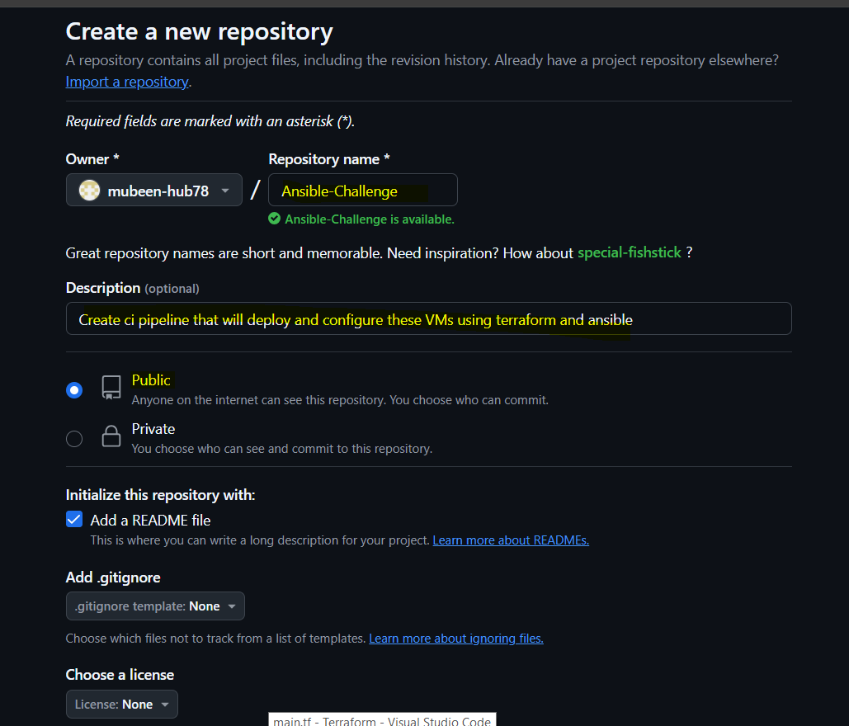

Directory structure in repo for Terraform ansible and pipeline:

Ansible-Challenge/
├── Jenkinsfile
├── terraform/
│ ├── main.tf
│ ├── variables.tf
│ ├── outputs.tf
│ └── provider.tf
├── ansible/
│ ├── inventory.ini (generated from Terraform output)
│ ├── playbook.yml
│ └── roles/
│ ├── common/
│ │ ├── tasks/
│ │ │ └── main.yml
│ ├── frontend/
│ │ ├── tasks/
│ │ │ ├── main.yml
│ │ │ └── proxy.yml
│ │ └── handlers/
│ │ └── main.yml
│ └── backend/
│ ├── tasks/
│ └── main.yml
│
└── README.md

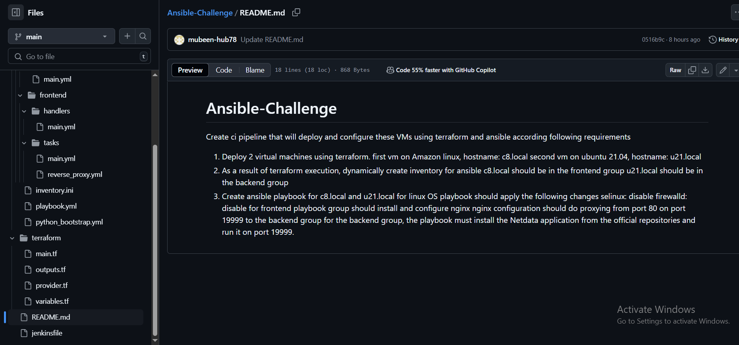

Jenkinsfile:
pipeline {
agent any

environment {
AWS_ACCESS_KEY_ID = credentials('AWS-ROOT')
AWS_SECRET_ACCESS_KEY = credentials('AWS-ROOT')
}

stages {
stage('Clone Repository') {
steps {
git branch: 'main', url: 'https://github.com/mubeen-hub78/Ansible-Challenge.git'
}
}

stage('Terraform Init') {
steps {
dir('terraform') {
sh 'terraform init'
}
}
}

stage('Terraform Apply') {
steps {
dir('terraform') {
sh 'terraform apply -auto-approve'
}
}
}

stage('Generate Ansible Inventory') {
steps {
dir('terraform') {
sh 'terraform output -raw inventory > ../ansible/inventory.ini'
}
}
}

stage('Run Ansible Playbook') {
steps {
dir('ansible') {
sshagent (credentials: ['Ubuntu']) {
sh '''
ansible-playbook -i inventory.ini playbook.yml --ssh-extra-args="-o StrictHostKeyChecking=no"
'''
}
}
}
}
}
}

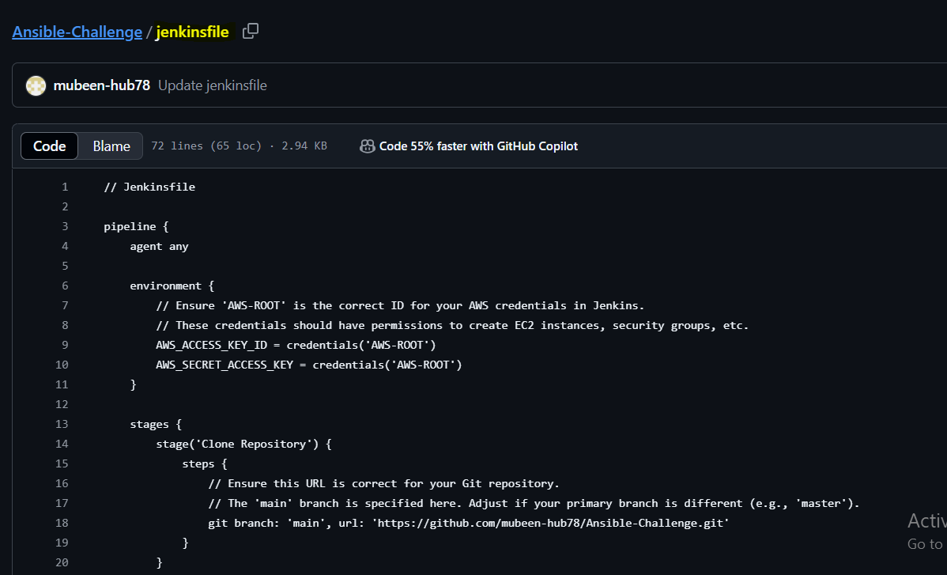

Environment Block
environment { ... } → Sets environment variables for AWS access.
credentials('AWS-ROOT') → Jenkins pulls AWS credentials by ID from its credential store.

Stage: Clone Repository
git branch: 'main' ... → Clones your GitHub repo from the main branch.

Stage: Terraform Init
dir('terraform') → Changes working directory to terraform/.
terraform init → Initializes Terraform (downloads providers, sets up backend).

Stage: Terraform Apply
terraform apply -auto-approve → Applies the infrastructure code without prompt.

Stage: Generate Ansible Inventory
terraform output -raw inventory > ../ansible/inventory.ini →
Gets inventory string and saves it to inventory.ini in the Ansible folder.

Stage: Run Ansible Playbook
- dir('ansible') → Enters the Ansible directory.
- sshagent(credentials: ['Ubuntu']) → Loads the SSH private key with ID Ubuntu from Jenkins credentials.
- ansible-playbook -i inventory.ini playbook.yml ... →
Runs the playbook using the dynamic inventory and disables strict host key checking for new VMs.

Now we have to update terraform all templates .tf files and Ansible all .yml as per our required challenge configuration.

Terraform Configuration:
main.tf

resource "aws_security_group" "web_sg" {
name_prefix = "ansible-challenge-sg-"
description = "Allow HTTP, SSH, and Netdata traffic for Ansible Challenge"

ingress {
from_port = 22
to_port = 22
protocol = "tcp"
cidr_blocks = ["0.0.0.0/0"]
}

ingress {
from_port = 80
to_port = 80
protocol = "tcp"
cidr_blocks = ["0.0.0.0/0"]
}

ingress {
from_port = 19999
to_port = 19999
protocol = "tcp"
cidr_blocks = ["0.0.0.0/0"]
}

egress {
from_port = 0
to_port = 0
protocol = "-1"
cidr_blocks = ["0.0.0.0/0"]
}
}

# Frontend VM (Amazon Linux 2)
resource "aws_instance" "frontend" {
ami = "ami-0f3f13f145e66a0a3"
instance_type = "t2.micro"
key_name = var.key_name # This will now reference an *existing* key pair in AWS
subnet_id = var.subnet_id
vpc_security_group_ids = [aws_security_group.web_sg.id]
tags = {
Name = "c8.local"
}

user_data = <<-EOF
#!/bin/bash
hostnamectl set-hostname c8.local
EOF
}

# Backend VM (Ubuntu 24.04 LTS)
resource "aws_instance" "backend" {
ami = "ami-020cba7c55df1f615"
instance_type = "t2.micro"
key_name = var.key_name # This will now reference an *existing* key pair in AWS
subnet_id = var.subnet_id
vpc_security_group_ids = [aws_security_group.web_sg.id]
tags = {
Name = "u21.local"
}

user_data = <<-EOF
#!/bin/bash
hostnamectl set-hostname u21.local
EOF
}

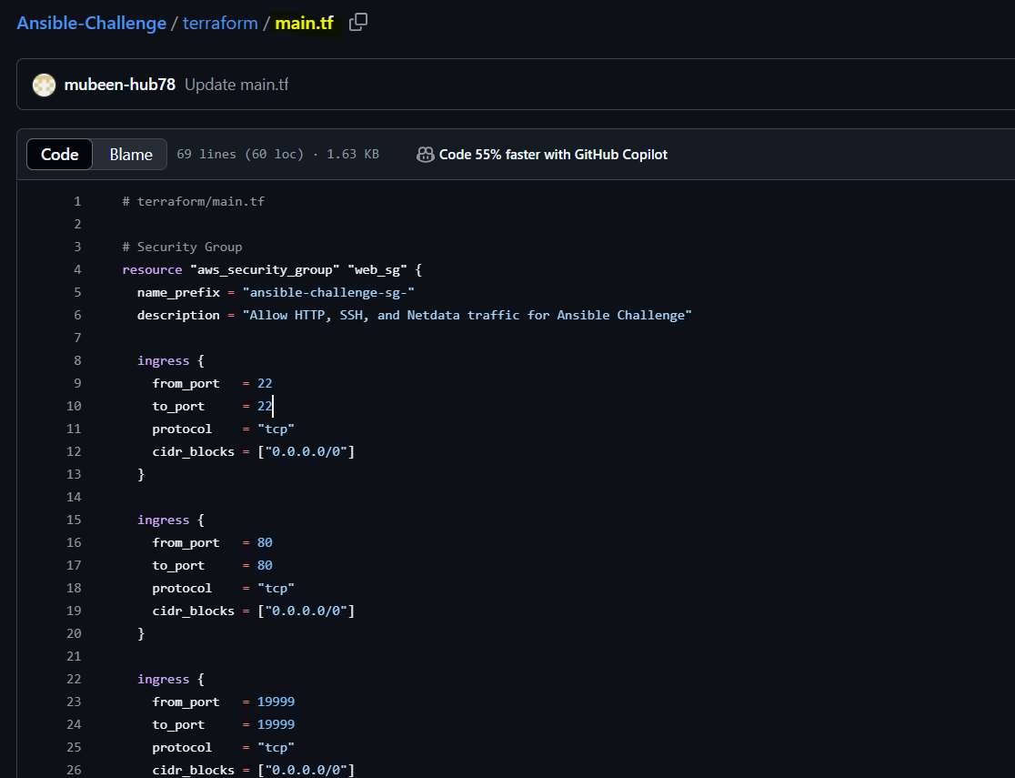

resource → Declares AWS resource type.
"aws_security_group" "web_sg" → Creates a security group named web_sg.
name_prefix → Auto-generates security group name starting with this prefix.
ingress → Opens ports 22 (SSH), 80 (HTTP), 19999 (Netdata) for all IPs.
egress → Allows all outbound traffic.
aws_instance "frontend" → Launches EC2 for frontend (Amazon Linux 2).
ami → Amazon Linux 2 image ID.
instance_type → EC2 type (t2.micro).
key_name → SSH key to access the instance.
subnet_id → Deploys in specified subnet.
vpc_security_group_ids → Attaches created security group to instance.
tags → Labels the instance as c8.local.
user_data → Runs a shell script at boot to set hostname.
aws_instance "backend" → Launches EC2 for backend (Ubuntu 24.04).
Backend config → Same as frontend, but with Ubuntu AMI and hostname u21.local.

variables.tf

variable "key_name" {
description = "The name of the existing EC2 Key Pair to access the instances"
type = string
default = "Virginia" # Your specified key name
}

variable "subnet_id" {
description = "The Subnet ID where EC2 instances will be launched"
type = string
default = "subnet-03edc94baf3c761fe" # Your specified subnet ID
}

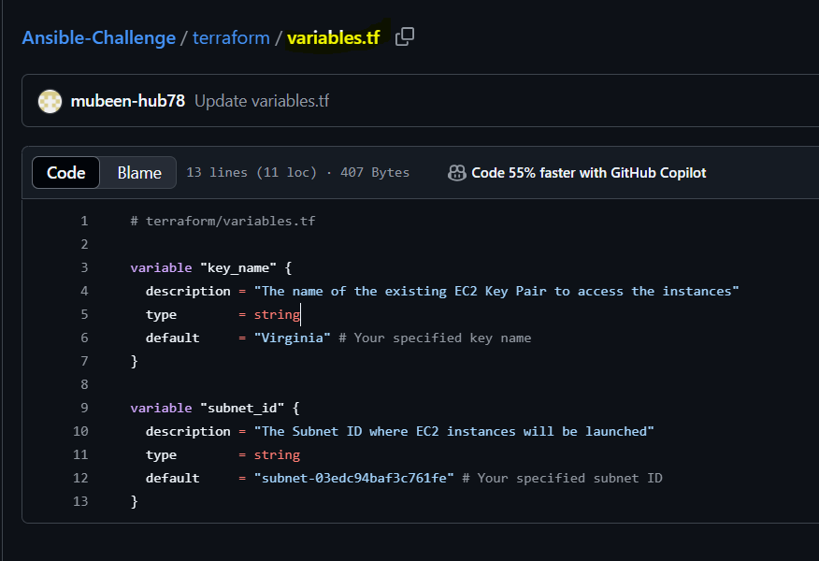

variable "<name>" {} → Declares a Terraform input variable.
key_name → Stores the name of the existing EC2 key pair (for SSH access).
description → Describes the purpose of the variable.
type = string → The variable accepts string values only.
default = "Virginia" → Default key name if not passed during runtime.

subnet_id → Stores the subnet ID where EC2 instances will be launched.
description → Explains that this is the target subnet for EC2.
type = string → String type variable.
default = "subnet-03edc94baf3c761fe" → Default subnet ID if not provided during runtime.

outputs.tf

output "frontend_ip" {
description = "Public IP address of the frontend server"
value = aws_instance.frontend.public_ip
}

output "backend_ip" {
description = "Public IP address of the backend server"
value = aws_instance.backend.public_ip
}

output "inventory" {
description = "Ansible inventory for the deployed instances"
value = <<EOT
[frontend]
# Explicitly tell Ansible to use Python 3.8 for c8.local, as this will be installed.
c8.local ansible_host=${aws_instance.frontend.public_ip} ansible_user=ec2-user ansible_python_interpreter=/usr/bin/python3.8

[backend]
# Ubuntu's /usr/bin/python3 (e.g., Python 3.12 for 24.04) is sufficient.
u21.local ansible_host=${aws_instance.backend.public_ip} ansible_user=ubuntu ansible_python_interpreter=/usr/bin/python3

[redhat_hosts]
c8.local

[debian_hosts]
u21.local

EOT
}

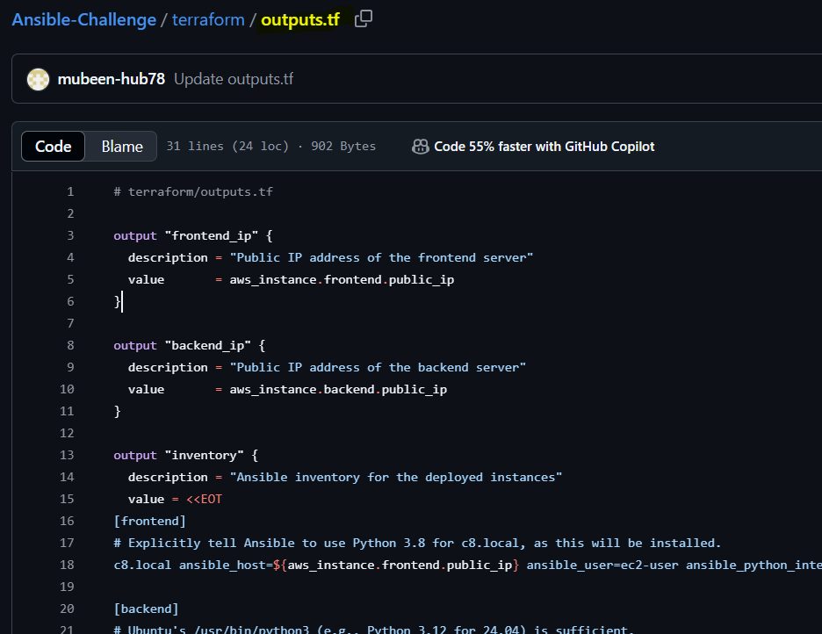

output "<name>" {} → Declares an output variable to display after terraform apply.

frontend_ip
Purpose: Displays the public IP of the frontend EC2.
description → Explains what this output shows.
value → Fetches the public IP of the frontend instance.

backend_ip
Purpose: Displays the public IP of the backend EC2.
description → Explains what this output shows.
value → Fetches the public IP of the backend instance.

inventory
Purpose: Generates Ansible dynamic inventory automatically.
description → Explains this is the inventory for Ansible.
value = <<EOT ... EOT → Multi-line string (Heredoc syntax) for Ansible inventory.

Inside inventory:
[frontend] → Creates the frontend group in Ansible.
c8.local ansible_host=... → Maps hostname to its public IP, sets SSH user and Python path.
[backend] → Creates the backend group in Ansible.
u21.local ansible_host=... → Maps hostname to its public IP, sets SSH user and Python path.
[redhat_hosts] → Creates a host group for RedHat-based systems.
[debian_hosts] → Creates a host group for Debian-based systems.

provider.tf

provider "aws" {
region = "us-east-1"
}

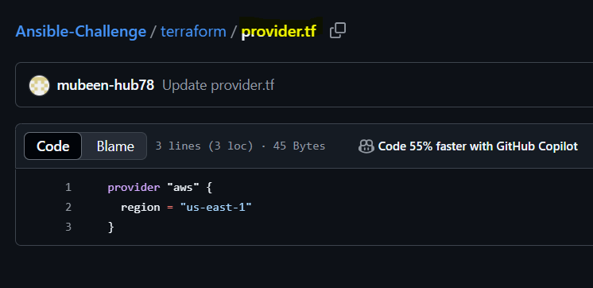

provider "aws" {} → Declares AWS as the cloud provider.
region = "us-east-1" → Specifies the AWS region to deploy resources (N. Virginia region).

Ansible Configuration

inventory.ini
(This is generated by Terraform, no manual changes.)
playbook.yml

---
- name: Python Bootstrapping for RedHat-like systems
hosts: redhat_hosts
become: true
gather_facts: no
tasks:
- name: Install Python 3.8 on RedHat (c8.local) via amazon-linux-extras
raw: |
sudo amazon-linux-extras enable python3.8
sudo yum clean metadata
sudo yum install -y python3.8
register: python_install_result

- name: Debug RedHat Python install output
debug:
var: python_install_result.stdout_lines

- name: Set Python 3.8 as interpreter for RedHat hosts
set_fact:
ansible_python_interpreter: /usr/bin/python3.8

- name: Reset SSH connection to apply new interpreter
meta: reset_connection

- name: Common OS Configuration
hosts: all
become: true
roles:
- common

- name: Configure Frontend
hosts: frontend
become: true
roles:
- frontend

- name: Configure Netdata for Public Access
hosts: backend
become: true
tasks:
- name: Ensure Netdata binds to all IP addresses
blockinfile:
path: /etc/netdata/netdata.conf
block: |
[web]
bind to = 0.0.0.0
marker: ""
insertafter: EOF
backup: yes

- name: Restart Netdata service
service:
name: netdata
state: restarted
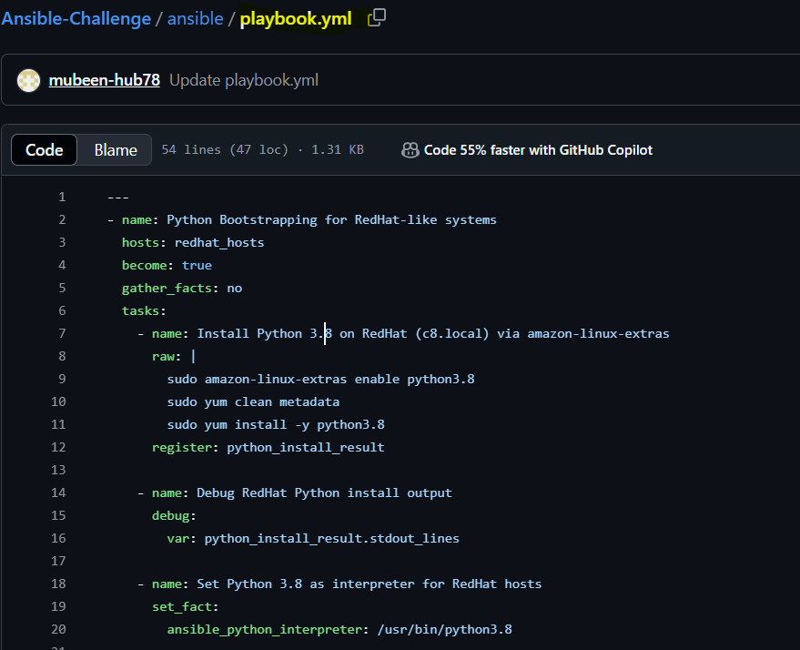

- hosts: redhat_hosts → Targets RedHat-based systems (like Amazon Linux).
- gather_facts: no → Skips automatic fact collection (because Python isn’t installed yet).
- raw → Runs shell commands directly without Python.
- amazon-linux-extras enable python3.8 → Enables Python 3.8 package source.
- yum install -y python3.8 → Installs Python 3.8.
- register → Captures command output.
- debug → Prints the install result.
- set_fact → Defines the Python interpreter path for future tasks.
- meta: reset_connection → Forces Ansible to reconnect using the new Python interpreter.

ansible/roles/common/tasks/main.yml
---
- name: Disable SELinux (RedHat-like systems excluding Amazon Linux)
when: ansible_facts['os_family'] == "RedHat" and ansible_facts['distribution'] != "Amazon"
command: setenforce 0

- name: Disable firewalld (RedHat-like systems excluding Amazon Linux)
when: ansible_facts['os_family'] == "RedHat" and ansible_facts['distribution'] != "Amazon"
systemd:
name: firewalld
state: stopped
enabled: no

- name: Disable UFW (Debian-like systems)
when: ansible_facts['os_family'] == "Debian"
systemd:
name: ufw
state: stopped
enabled: no

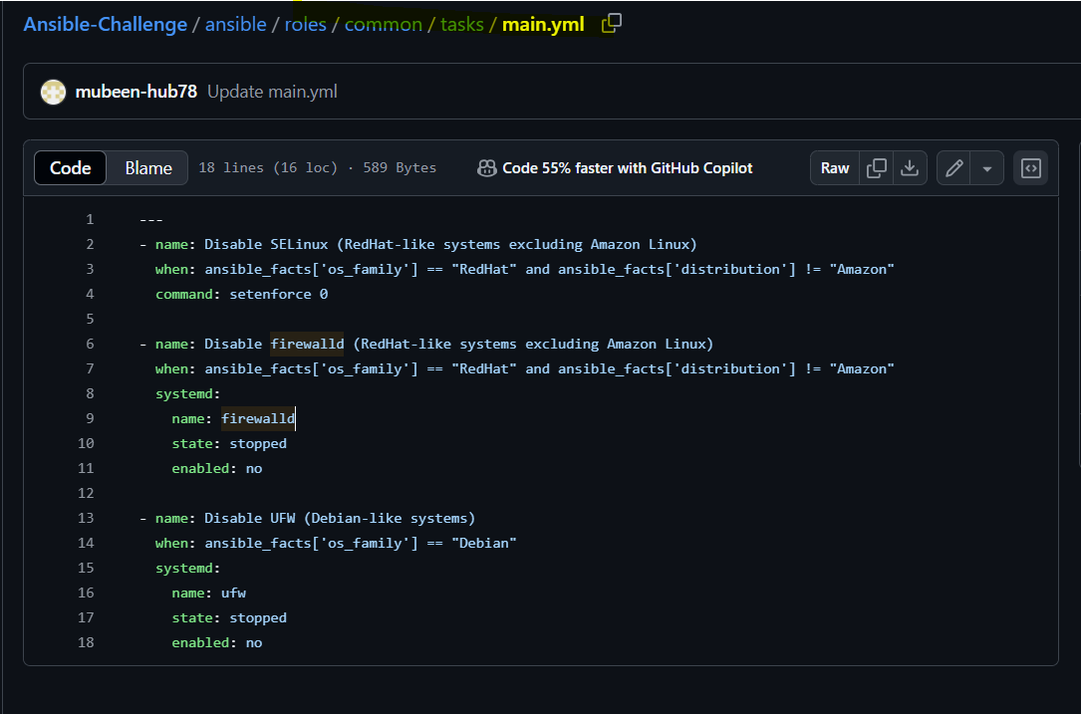

- name: Disable SELinux (RedHat-like systems excluding Amazon Linux)
→ Task name.
when: ansible_facts['os_family'] == "RedHat" and ansible_facts['distribution'] != "Amazon"
→ Runs only on RedHat systems except Amazon Linux.
command: setenforce 0
→ Disables SELinux temporarily.

- name: Disable firewalld (RedHat-like systems excluding Amazon Linux)
→ Task name.
when: ansible_facts['os_family'] == "RedHat" and ansible_facts['distribution'] != "Amazon"
→ Runs only on RedHat systems except Amazon Linux.
systemd: → Uses systemd module to control service.
name: firewalld → Targets firewalld service.
state: stopped → Stops the service.
enabled: no → Disables the service on boot.

- name: Disable UFW (Debian-like systems)
→ Task name.
when: ansible_facts['os_family'] == "Debian"
→ Runs only on Debian-based systems (like Ubuntu).
systemd: → Uses systemd module to control service.
name: ufw → Targets ufw firewall service.
state: stopped → Stops the service.
enabled: no → Disables the service on boot.

ansible/roles/frontend/tasks/main.yml
---
- name: Enable nginx using amazon-linux-extras
shell: amazon-linux-extras enable nginx1

- name: Clean yum metadata
shell: yum clean metadata

- name: Install Nginx using shell command
shell: yum install -y nginx

- name: Start and enable Nginx
systemd:
name: nginx
state: started
enabled: true
- include_tasks: reverse_proxy.yml

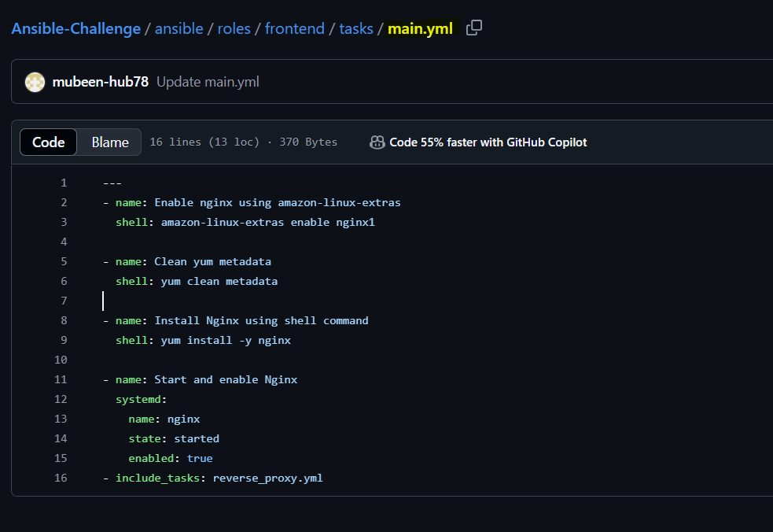
- name: Enable nginx using amazon-linux-extras
→ Task name.
shell: amazon-linux-extras enable nginx1
→ Enables nginx package source on Amazon Linux.
- name: Clean yum metadata
→ Task name.
shell: yum clean metadata
→ Clears yum cache to refresh package list.
- name: Install Nginx using shell command
→ Task name.
shell: yum install -y nginx
→ Installs nginx package.
- name: Start and enable Nginx
→ Task name.
systemd: → Uses systemd module to manage service.
name: nginx → Targets nginx service.
state: started → Starts nginx service.
enabled: true → Enables nginx on system boot.
- include_tasks: reverse_proxy.yml
→ Includes another task file named reverse_proxy.yml to run next.

ansible/roles/frontend/tasks/reverse_proxy.yml
- name: Add reverse proxy config for Netdata
copy:
dest: /etc/nginx/conf.d/netdata_proxy.conf
content: |
server {
listen 80;

location / {
proxy_pass http://{{ hostvars['u21.local']['ansible_host'] }}:19999;
proxy_set_header Host $host;
proxy_set_header X-Real-IP $remote_addr;
}
}
notify: restart nginx

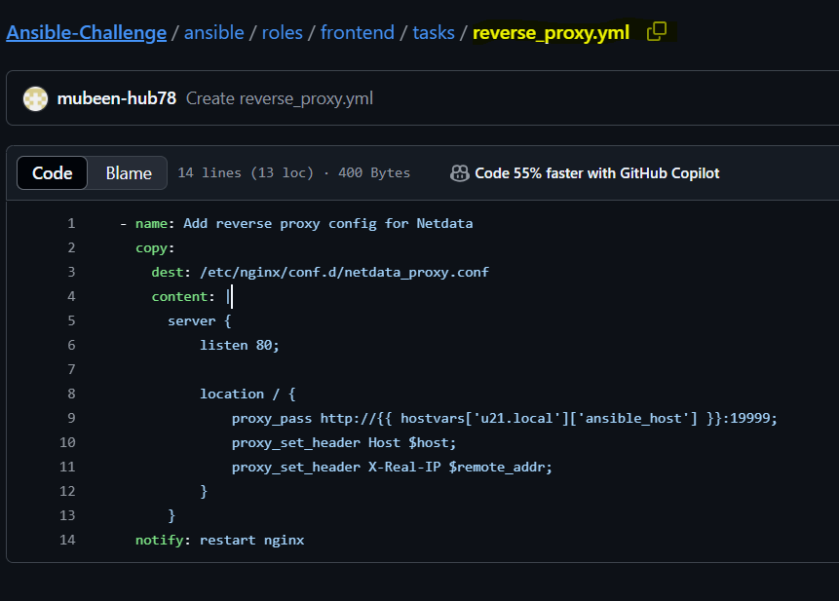

- name: Add reverse proxy config for Netdata
→ Task name.
copy: → Uses Ansible’s copy module to create a file.
dest: /etc/nginx/conf.d/netdata_proxy.conf
→ File path where the proxy config will be placed.
content: |
→ Multi-line Nginx reverse proxy configuration.
server { listen 80; ... }
→ Configures Nginx to listen on port 80 and proxy traffic to backend.
proxy_pass http://{{ hostvars['u21.local']['ansible_host'] }}:19999;
→ Forwards requests to backend’s Netdata service using its public IP.
proxy_set_header Host $host;
→ Passes original host header to backend.
proxy_set_header X-Real-IP $remote_addr;
→ Passes client’s real IP to backend.
notify: restart nginx
→ Triggers handler to restart Nginx after this task.

ansible/roles/frontend/handlers/main.yml
- name: restart nginx
service:
name: nginx
state: restarted

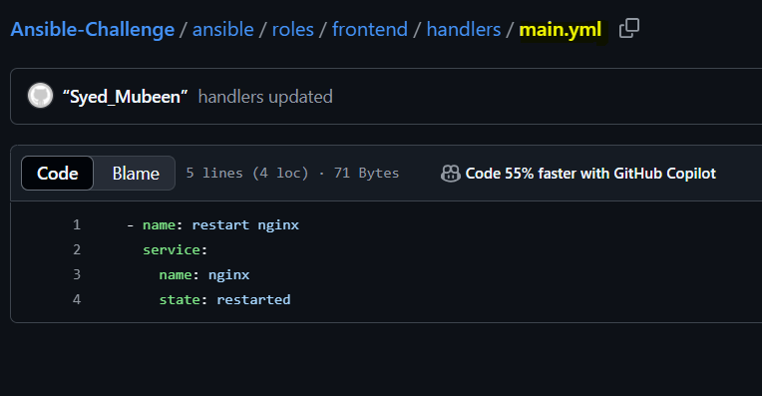

- name: restart nginx
→ Handler name.
service: → Uses Ansible’s service module.
name: nginx → Targets nginx service.
state: restarted → Restarts the nginx service.

ansible/roles/backend/tasks/main.yml
---
# Install Netdata on Debian-based systems
- name: Install Netdata on Debian/Ubuntu
apt:
name: netdata
state: present
update_cache: yes
when: ansible_os_family == "Debian"

# Install Netdata on RedHat-based systems (Amazon Linux 2 / CentOS)
- name: Install Netdata on RedHat/Amazon Linux
yum:
name: netdata
state: present
when: ansible_distribution in ["Amazon", "CentOS", "RedHat"]

# Configure Netdata to listen on all interfaces (port 19999)
- name: Configure Netdata to listen on all interfaces (port 19999)
lineinfile:
path: /etc/netdata/netdata.conf
regexp: '^\s*#?\s*bind to = 127.0.0.1'
line: ' bind to = 0.0.0.0'
backup: yes

# Ensure Netdata is running and enabled
- name: Ensure Netdata is running and enabled
service:
name: netdata
state: started
enabled: yes

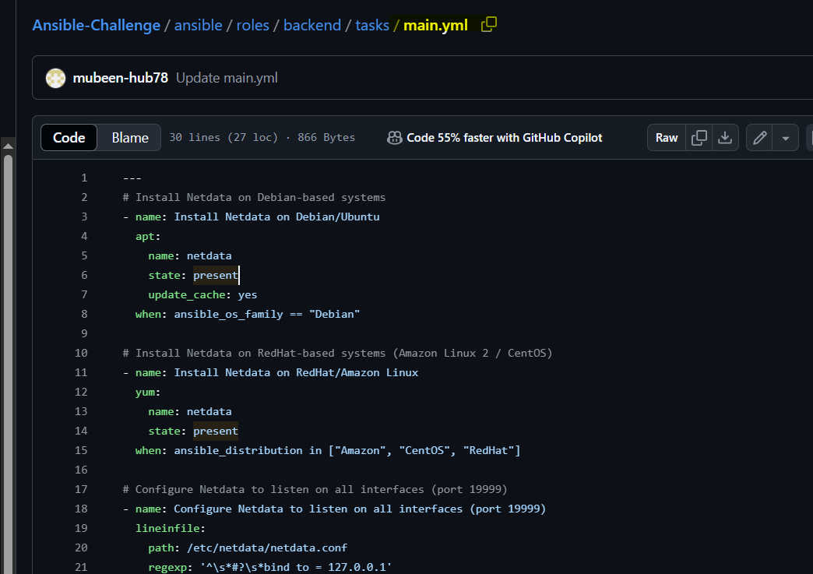

---
→ YAML document start.
- name: Install Netdata on Debian/Ubuntu
→ Task name.
apt: → Uses apt package manager for Debian-based systems.
name: netdata → Installs Netdata package.
state: present → Ensures Netdata is installed.
update_cache: yes → Updates apt cache before installing.
when: ansible_os_family == "Debian"
→ Runs only on Debian-based systems.

- name: Install Netdata on RedHat/Amazon Linux
→ Task name.
yum: → Uses yum package manager for RedHat-based systems.
name: netdata → Installs Netdata package.
state: present → Ensures Netdata is installed.
when: ansible_distribution in ["Amazon", "CentOS", "RedHat"]
→ Runs only on Amazon Linux, CentOS, or RedHat systems.

- name: Configure Netdata to listen on all interfaces (port 19999)
→ Task name.
lineinfile: → Uses lineinfile module to update config file.
path: /etc/netdata/netdata.conf → Target configuration file.
regexp: '^\s*#?\s*bind to = 127.0.0.1' → Searches for existing bind line.
line: ' bind to = 0.0.0.0' → Updates bind to listen on all IPs.
backup: yes → Creates backup of original file.

- name: Ensure Netdata is running and enabled
→ Task name.
service: → Uses service module to manage services.
name: netdata → Targets netdata service.
state: started → Starts netdata service.
enabled: yes → Enables netdata to start on boot.

Jenkins Pipeline Prerequisites (Checklist)
- Jenkins Installed and Running
- Required Jenkins Plugins:
  - Git Plugin ✅
  - Pipeline Plugin ✅
  - Credentials Binding Plugin ✅
  - SSH Agent Plugin ✅
- Jenkins Credentials:
  - AWS Credentials ID: AWS-ROOT (must contain AWS Access Key ID and Secret Access Key)
- Tools Installed on Jenkins Node:
  - Terraform ✅
  - Ansible ✅
  - Git ✅
  - AWS CLI ✅
- Ansible SSH Configuration:
  - Virginia.pem key file present on Jenkins node
  - ansible.cfg configured to use Virginia.pem OR pass --private-key in the playbook command
- Network Setup:
  - EC2 Security Group allows:
    - Port 22 (SSH) from Jenkins server IP
    - Port 80 (HTTP) if using Nginx
    - Other required ports if needed
- Repository Access:
  - Jenkins server has internet access to clone from:
https://github.com/mubeen-hub78/Ansible-Challenge.git

Make sure to have all this setup, installations, plugins and credentials.

Create a Pipeline job,

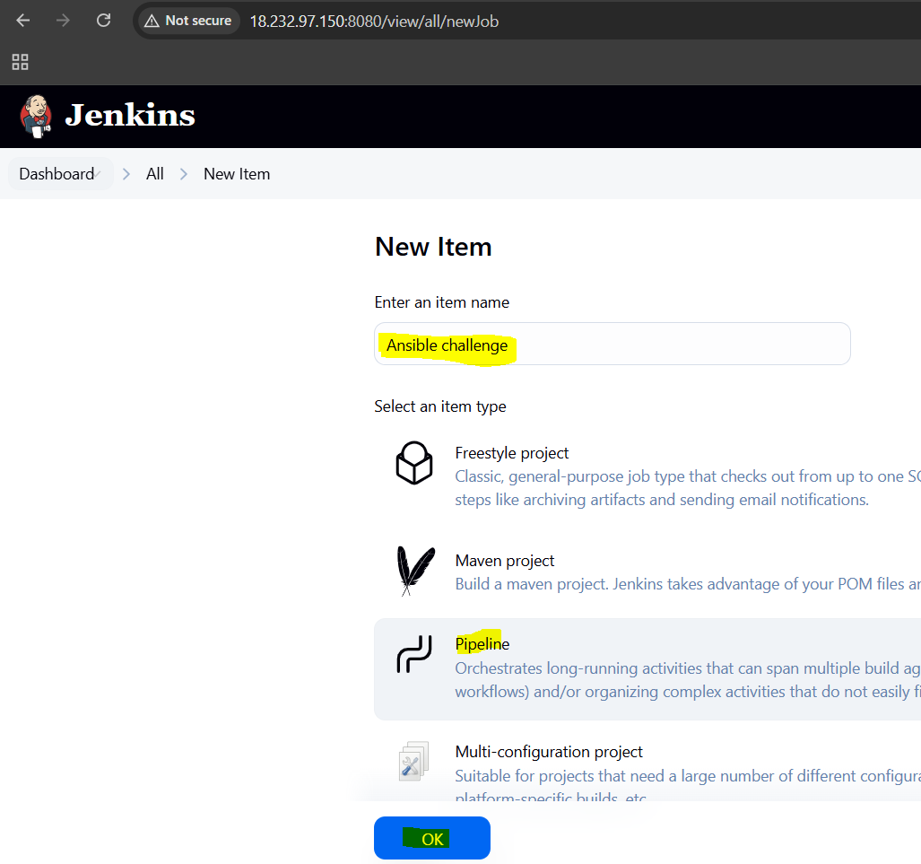

Add pipeline to the job,
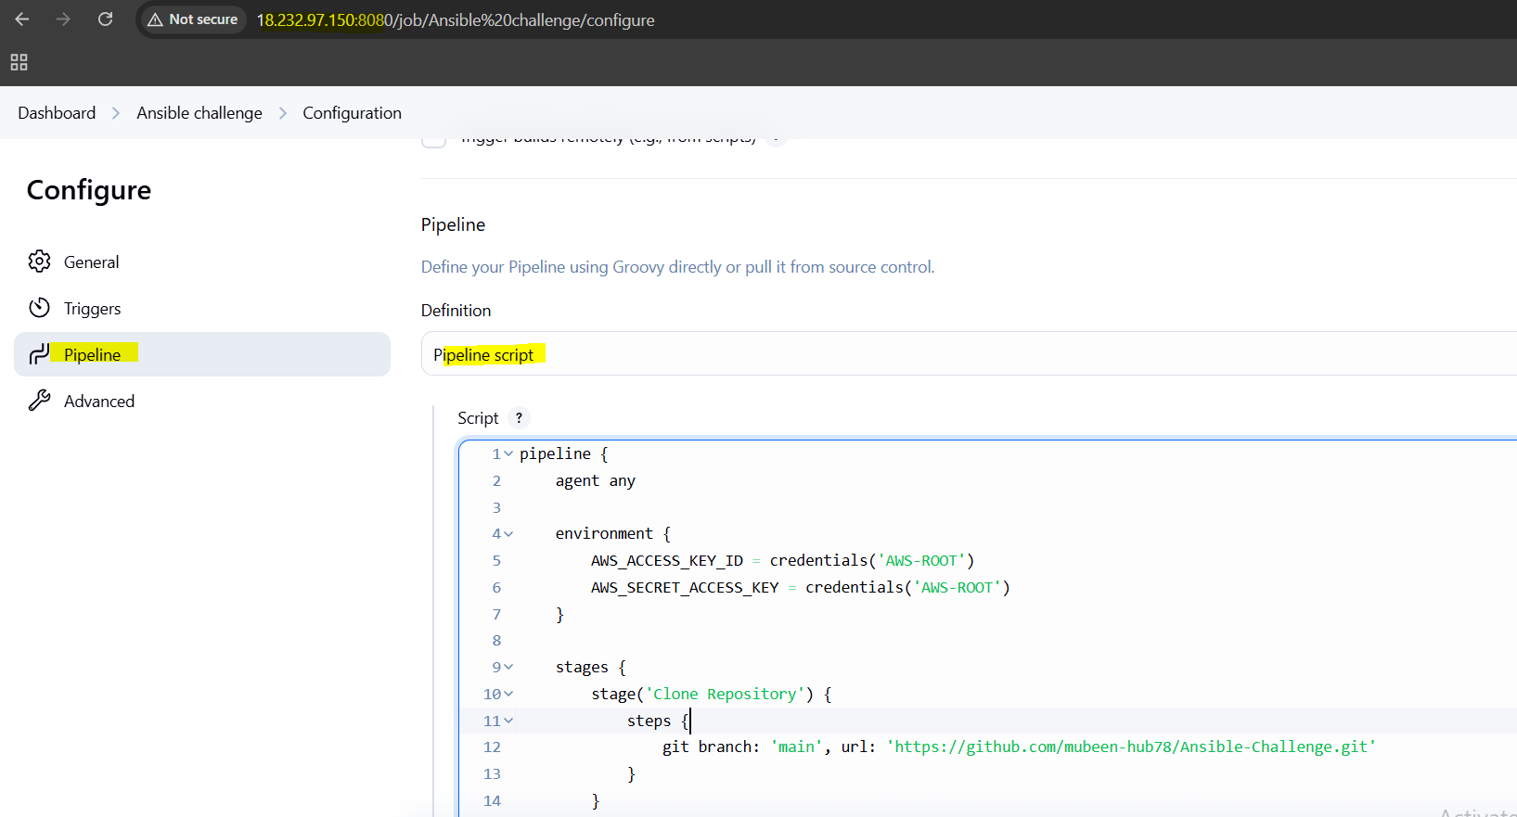

Click on Build now.
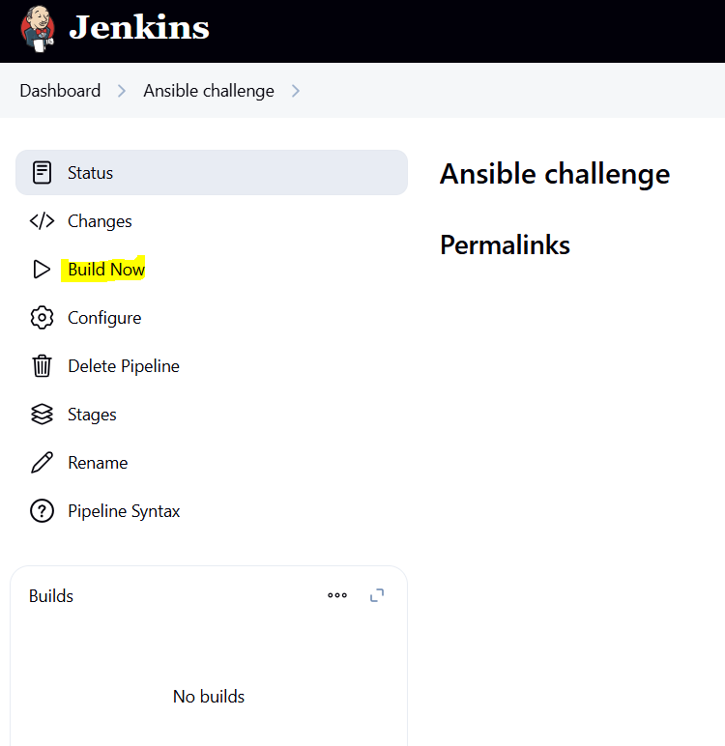

Console output,
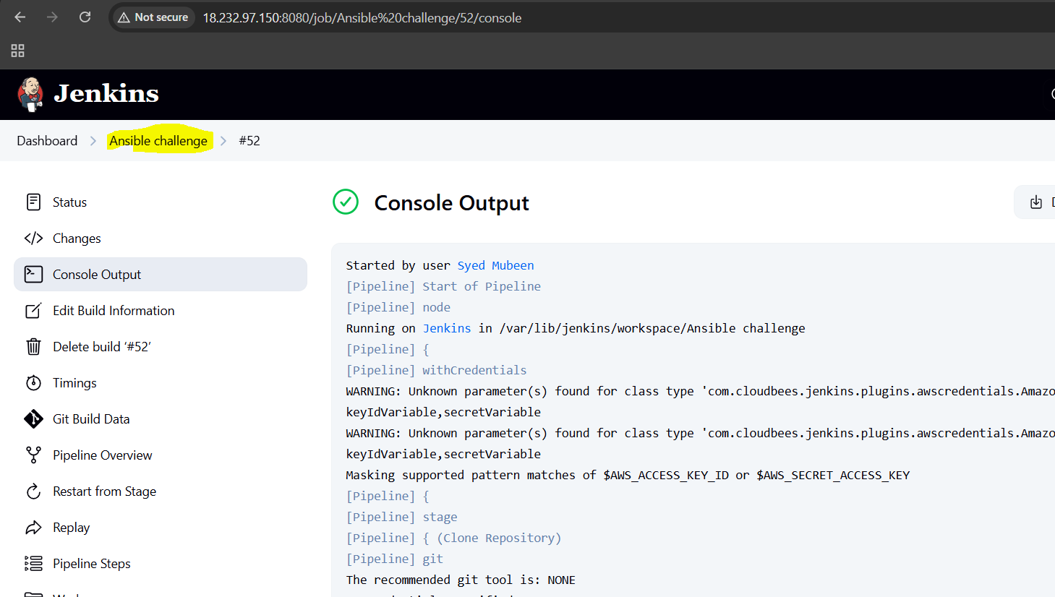
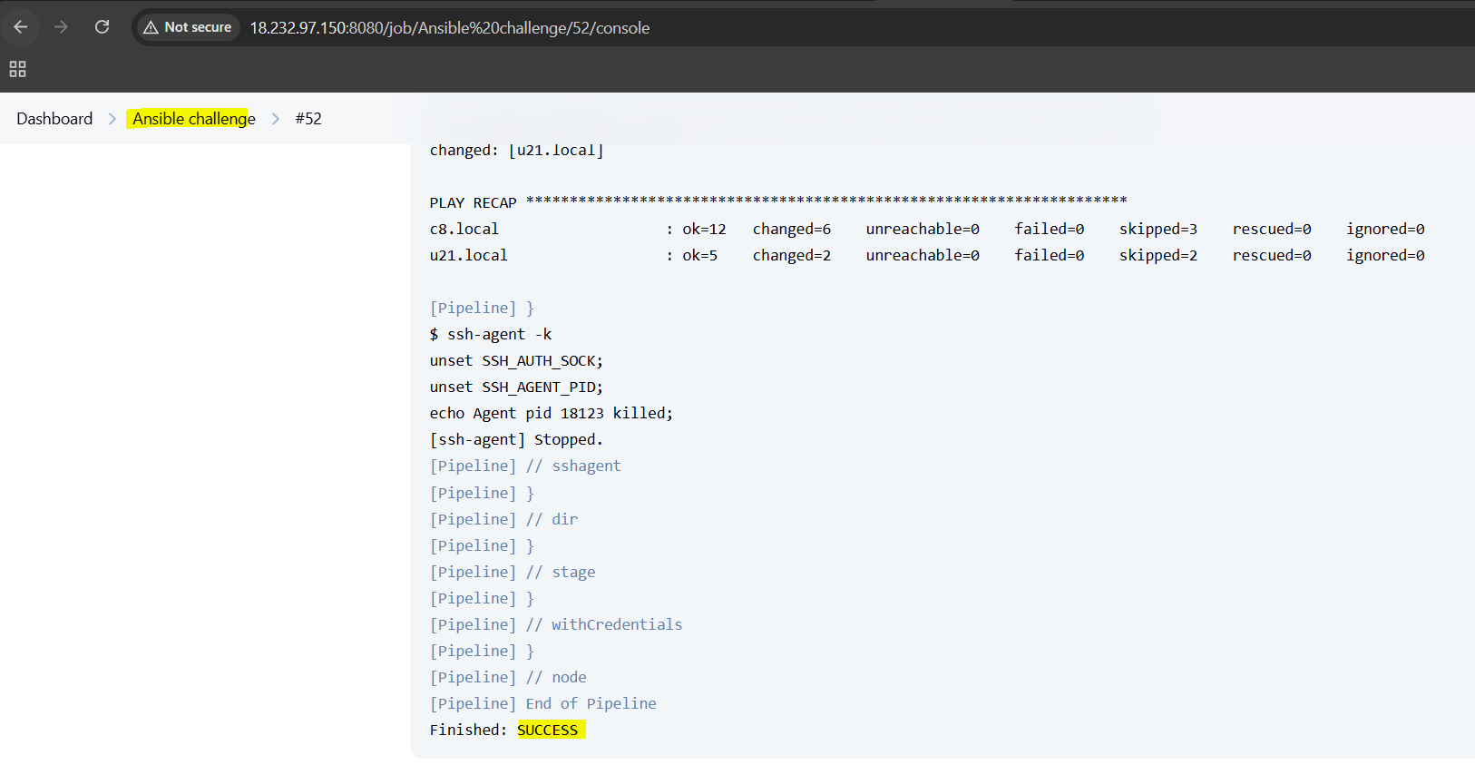

Instances verification

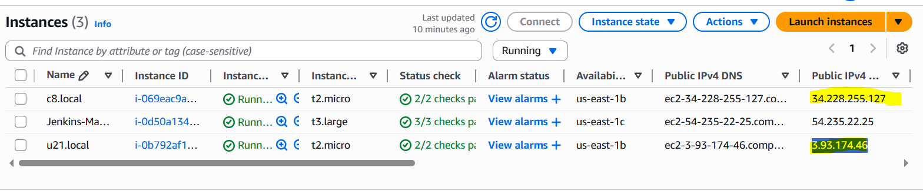

Frontend

Backend

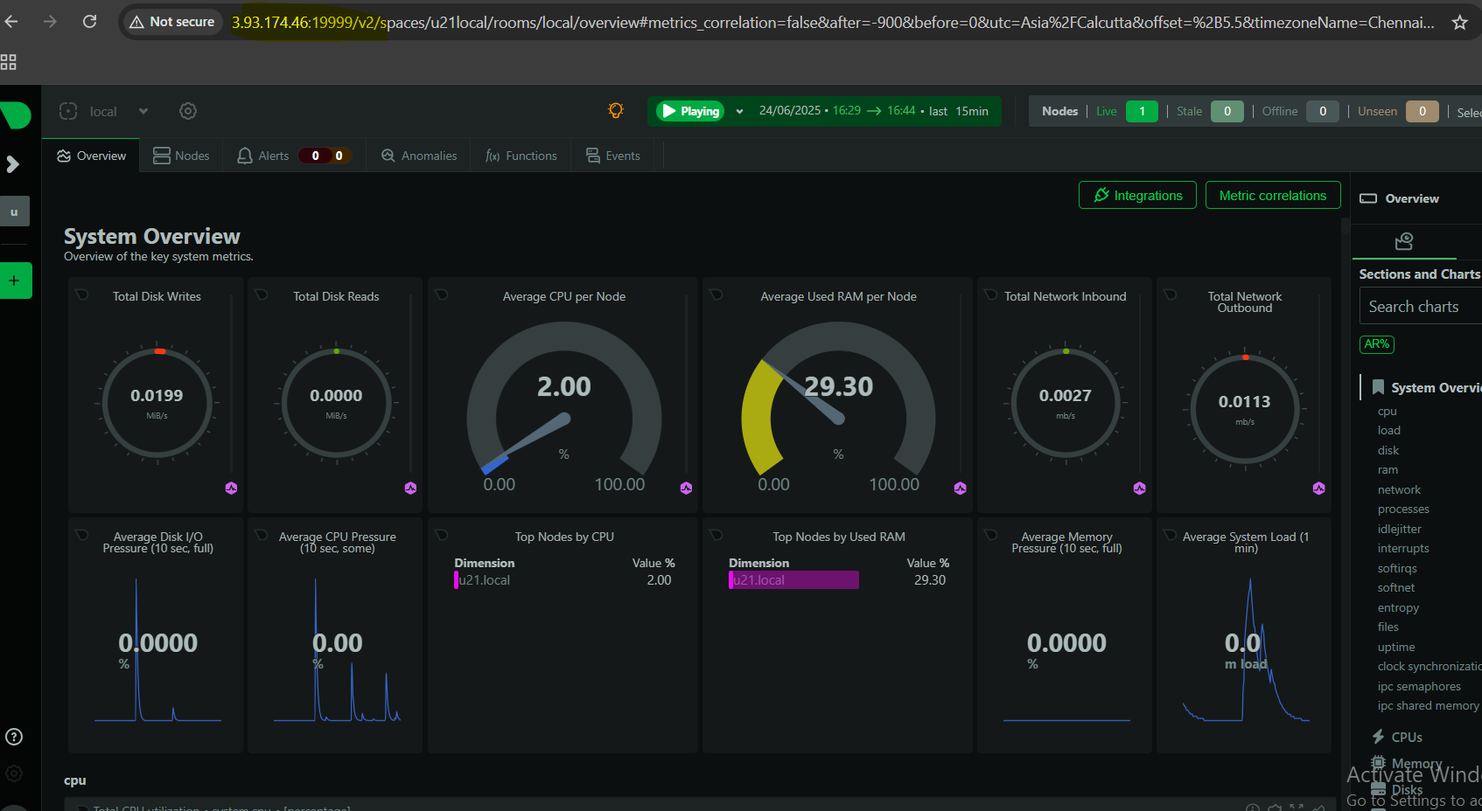

THE-END

